Shivagadhi English School
Class: 10 Supplimenrty Examination 2081 F.M.: 75
Time : 3hrs Subject: C. Math PM: 30
Attempt all the questions

1. In a survey of 300 people, it was found that 150 people liked I-phone and 200 people like Android phone. But 25 people did not like any of these two phones.
- If I and A denote the sets of people who like I-phone and Android Phone respectively, write the cardinality of n$\overline{(IUA)}$. [1]
- Present the above information in a Venn-diagram. [1]
- Find the number of people who liked I-phone only. [3]
- Compare the number of people who like both I-phone and Android phone and who do not like any of these two phones. [1]
2. A retired teacher deposited Rs.80,000 in own account of development bank for two years to get the half yearly compound interest at the rate of 10% per annum.
- How many times the interest is calculated according to the semi- annual compound interest in 2 years? Write it.[1]
- According to the half yearly compound interest, what would be the compound interest received by teacher at the end of 2 years? Find it. [2]
- According to the same rate of yearly compound interest, in how many years will the compound amount of Rs. 80,000 be Rs. 1,06,480 ? Find it. [2]
3. A minibus is purchased for Rs.40,00,000. After using bus for three years. Rs.15,00,000 is earned. The value of the bus depreciates by the rate of 15% per annum and the minibus is sold after three years.
- If the purchasing price of the bus is Rs.V_{o}, the annual rate of compound depreciation is R% and price of the bus after T years is Rs.V_{T}, then express V_{T} in terms of V_{o}, R% and T.[1]
- Find the selling price of the bus after three years. [2]
- Find the total profit or loss in percent through the total transaction of that minibus. [2]
4. A man went to the Bank to exchange American dollars to visit abroad. In that day, according to the money exchange rate, the buying rate of American Dollar is Rs.132 and selling rate is Rs.133.
- How many dollars does the man receive while exchanging American dollar with Rs. 332500? Find it. [1]
- How much Nepali rupees does his friend receive while exchanging American dollar 2800 in the same day? Find it. [2]
- After 10 days, the selling rate for American dollar 1 becomes Rs.138.32 then by what percent the Nepali currency was devaluated? Find it. [2]
5. The height of a square based pyramid is 21cm and the length of the base is 20cm.
- How many triangular surfaces are there in a square based pyramid? Write it. [1]
- Find the slant height of the pyramid. [2]
- What is the total cost of painting the total surface area of the Pyramid at the rate of Rs.5 per square cm? Find it.[2]

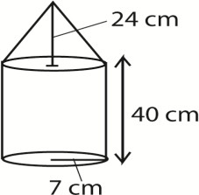
6. A metallic solid made up of a cone and a cylinder is given in the figure. The radii of the base of the cone and cylinder are equal. The height of the cylinder is 40cm, height of the cone is 24cm and radius of the base of cone is 7cm.

If radius of the base and slant height of the cone is given then write the formula for finding the curved surface area of the cone. [1]

Find the volume of the solid object.[2]

Compare the volume of the cylindrical part and the volume of conical part? [2]
7. In a cylindrical water tank 30 cement wheels each of 14ft diameter and 2ft height are placed. The cost of making that tank is rs2500 per wheel. If 2 workers can prepare that tank in 10 days at the rate of Rs 1500 per worker per day. (1 cubic ft = 28.317l)
a. How much is the total cost of building the tank? 3
b. If the tank has 15 rings of water , then how many liters of water are in the tank? Find how many liters of water is required to fill the tank. 2
8. The length, breadth and height of a rectangular room are 14 ft, 13 ft, and 10 ft respectively. There are two square windows with 3 feet edges and two doors of size 6ft × 3ft in the room.
- How much does it cost to paint four walls and ceiling of the room excluding doors and windows at the rate of Rs.36 per square feet? Find it [3]
- How much the total cost will increase to paint on same part if the cost of painting per square meter is increased by one third of what it was before due to the increase in the market price? Find it. [2]
9. There are 4 geometric means between 3 and 243.
- First term 'a', last term 'b' and number of geometric means 'n' are given. Write the formula for the calculation of common ratio in the given condition. [1]
- What is the third mean of the given series? Find it. [1]
- In arithmetic mean and geometric mean between 3 and 243, which one is greater and by how much? Compare it. [2]

10. A circle with center O has central angle $⊾ EOG-110$⁰ and EFGH is a cyclic quadrilateral.

a. Write the relation between the opposite angles of cyclic quadrilateral.1
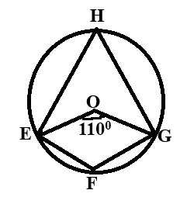

b. Find the value of $⊾$EHG. 1

c. Verify experimentally that opposite angles of cyclic quadrilateral are supplementary [Two circles having at least 3cm radii are necessary] (3)

11. From the top of a tower, the angle of depression to the roof of a house 15 m high and 50m away from the base of the tower, was observed and found to be 45⁰.
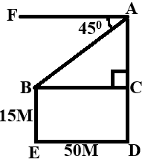

a) Find the value of $∡$ABC. 1

b) Find the measure of AC. 1

c) Find the height of tower. 1

d) What will happen to the angle of depression

when tower's height increases.1

12. In the given figure, height of pole with bulb (AB) = 20.5m and the height of man (CD) = 1.5 m
a) Define the angle of elevation. [1]
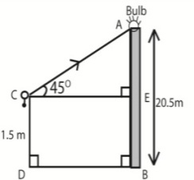
b) How much is the height of man less than the height of the pole with bulb? Write it.[1]
c) If the angle of elevation ECA = 45⁰, then find the
distance between the man and pole. [1] man and pole.[1]
d) When the man looks at the top of the pole with bulb, how far does he move forward or backward from the current position so that the angle of elevation may be 30⁰? Find it.[2]
13. The data given below is the marks obtained by 20 students in an exam of Mathematics.
(Marks obtained) | 0-10 | 10-20 | 20-30 | 30-40 | 40-50
(No. of students) | 2 | 3 | 6 | 5 | 4
a. What does i denote in the formula. [1]
b. Find the median of the given data. [1]
c.Find the mode from the above data. [2]

14. In the figure, a cone is filled with ice- cream whose upper

part is hemispherical. The slant height of the cone is 25cm and its radius
is 7 cm.
- Write the relation among the height (h), radius (r) and slant
height (l) of the cone. [1]
- Find the total volume of ice-cream in conical and
hemi spherical parts. [2]
- Compare the quantities of ice-cream in the conical and
hemi- spherical parts. [1]
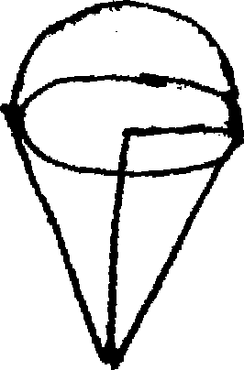
7cm

25 cm

15. Triangle PMN and parallelogram MNQR are on the same base MN and between the same parallel lines MN and PQ . Prove that area of parallelogram MNQR is twice of area of triangle PMN. [4]
16. A Square based solid pyramid has length of base 10cm and slant height 13cm.
- Write the relation among vertical height , length of base and slant height of the pyramid. 1

- Find the Vertical height of the pyramid. 1
- What is the volume of the pyramid? 1
- If the pyramid is submerged in a cubical container having internal length 50cm and filled with water, how many litres of water will it displace? 1

“BEST OF LUCK”
“HAPPY DASHAIN”

